

ACTIVITY 2



April 13, 2024

aUSTIN bECK

CST-350

Part 1

Screenshot 1: Products Index Page

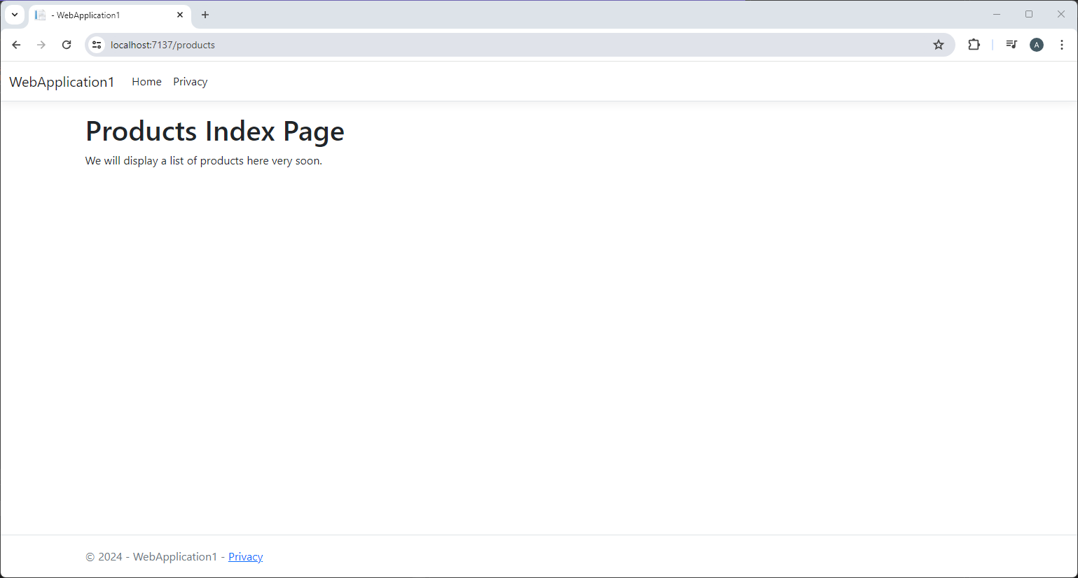

Screenshot 2: Message From Controller

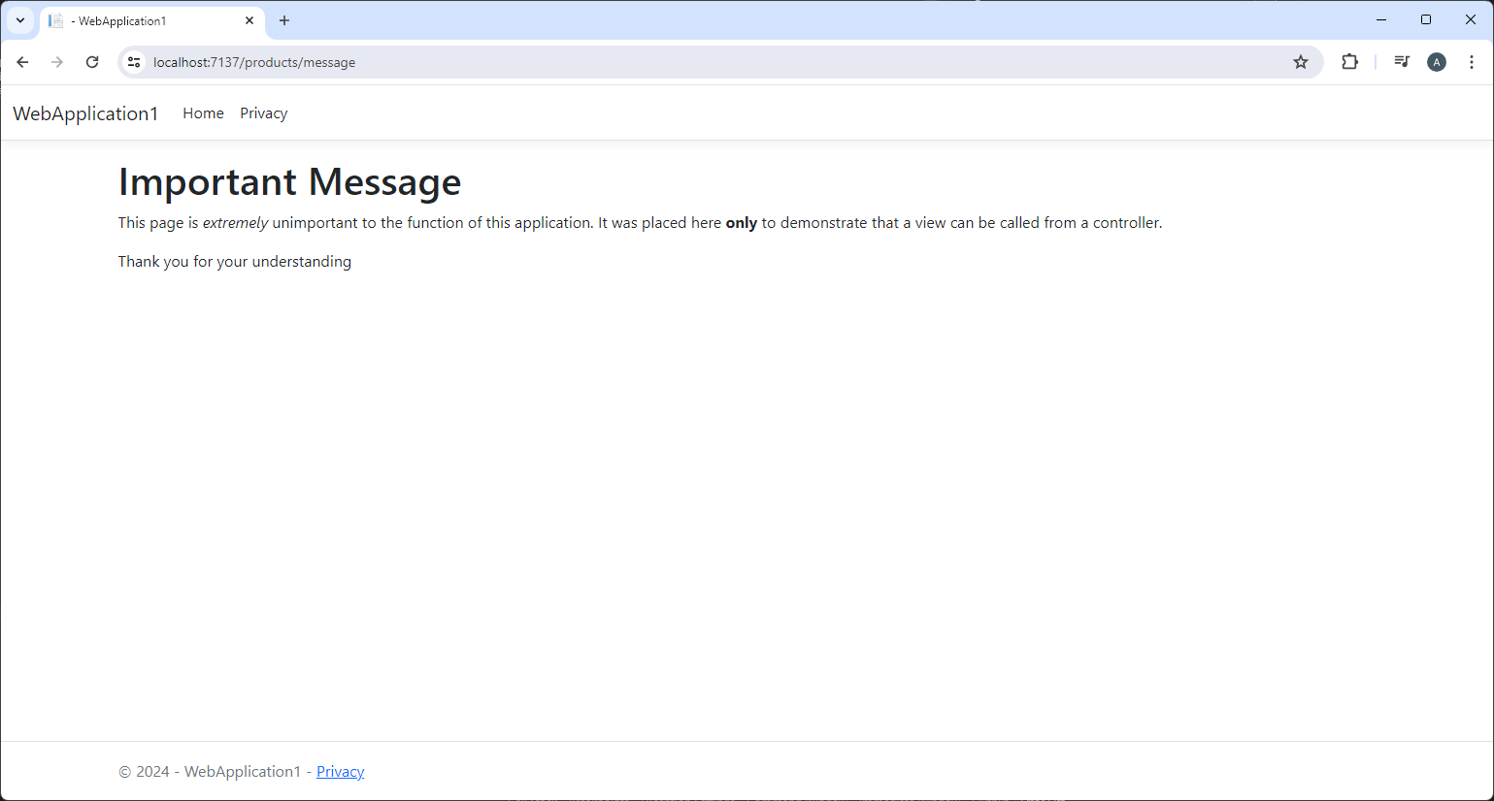

Screenshot 3: Product Message Page

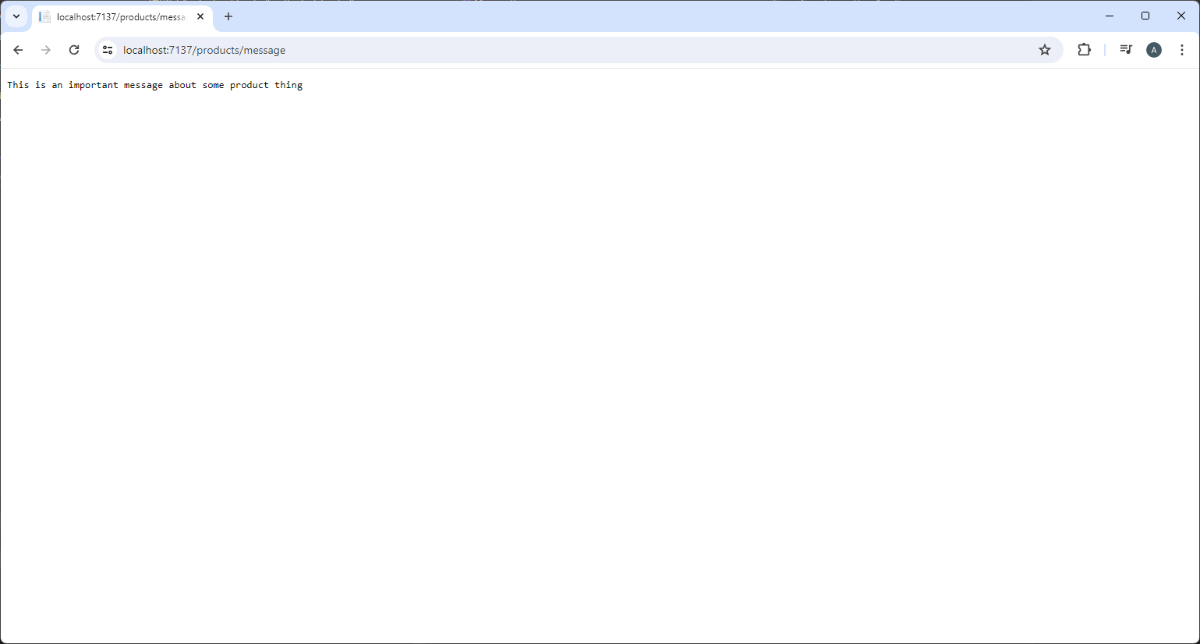

Screenshot 4: ViewBag Message

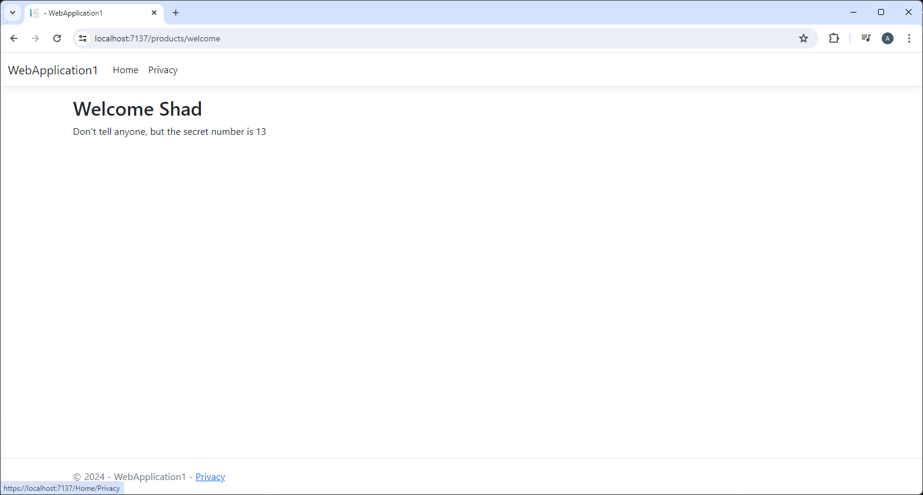

Part 2